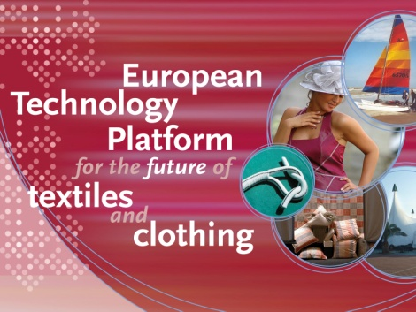
The European Technology Platform for the
Future of Textiles and Clothing, a.i.s.b.l.
24 rue Montoyer, Box 10,
B-1000 Brussels
 : + 32.2.285.48.85 Fax : +32.2.230.60.54
 : info@textile-platform.eu
Website : www.textile-platform.eu
VAT n° : BE 0524876007
_______________________________________________________________________________

Membership Data Input Form

Standard Members

Information about the member organisation
For inclusion into the membership listing on the ETP website www.textile-platform.eu
Full organisation name (preferably in English, if available)
Organisation short name (if commonly used)
Country (in case of multi-country organisations use the country of headquarter or of the unit that took the ETP membership subscription)
Organisation website

Information on individual experts to be involved in the ETP
Please provide below the names and e-mail addresses of all individual experts that will be involved in Textile ETP activities and receive direct information. Please select only areas in which you have genuine interest and expertise. Please provide maximum 2 names per category. Multiple appearance of the same person is possible.

ETP working area/expert group* | Full name | E-mail address
TEG1 - Fibres & fibre-composites
TEG2 - Functionalisation of textile materials & related processes
TEG3 - Biomaterials, biotechnologies and environmentally friendly textile processing
TEG4 - Innovative textile products for human performance (medical, protective, sports)
TEG5 – Innovative textile products for technical applications
TEG6 - Smart textiles & garments
TEG7 - New concepts & technologies for design and mass customisation in Clothing & Fashion
TEG8 - Integrated quality and life cycle management

HTG Higher Education
Protective Textiles and Clothing Lead Market
TFE1 – Sustainable textile raw materials
TFE2 – Resource-efficient textile processing
TFE3 – 3D Textile Manufacturing
TFE4 – Innovation textiles for Construction & Architecture
TFE5 – Innovation textiles for Marine applications
TFE6 – Innovation textiles for Agriculture and Landscaping
TFE7 – Digital Fashion
ETP General**
* The Thematic Expert Group (TEG) are permanent virtual expert groups existing since the start of the ETP in 2004 which do not organise regular meetings, but certain thematic information will be provided on the basis of TEG membership. The Textile Flagships for Europe (TFE) are active working groups which organise frequent meetings or conference calls, experts signed up for these groups should be willing and able to make active contributions to the group work. As a standard member you can select up to 4 TFE’s, but unlimited other groups.
** All above-listed names will only receive specific information relating to their selected expert group. Therefore add in the ETP General line the 1 person that will receive all the ETP information.

Central contact for general ETP membership issues
Contact person (full name):……..………………………..
Function:………………….
E-mail:………………..
Phone:………………..
Postal address:
………………………………………
………………………………………
………………………………………

Please return this form to:

Lutz Walter, Secretary General
e-mail: info@textile-platform.eu

